

**Core Java + Selenium**

Prerequisite Software’s that needs to be installed.

1. JDK: Which can be downloaded from the below URL. Based on the operating system and system architecture whether its 86 or 64 bit.

<http://www.oracle.com/technetwork/java/javase/downloads/jdk8-downloads-2133151.html>

Just accept the license and click on the download

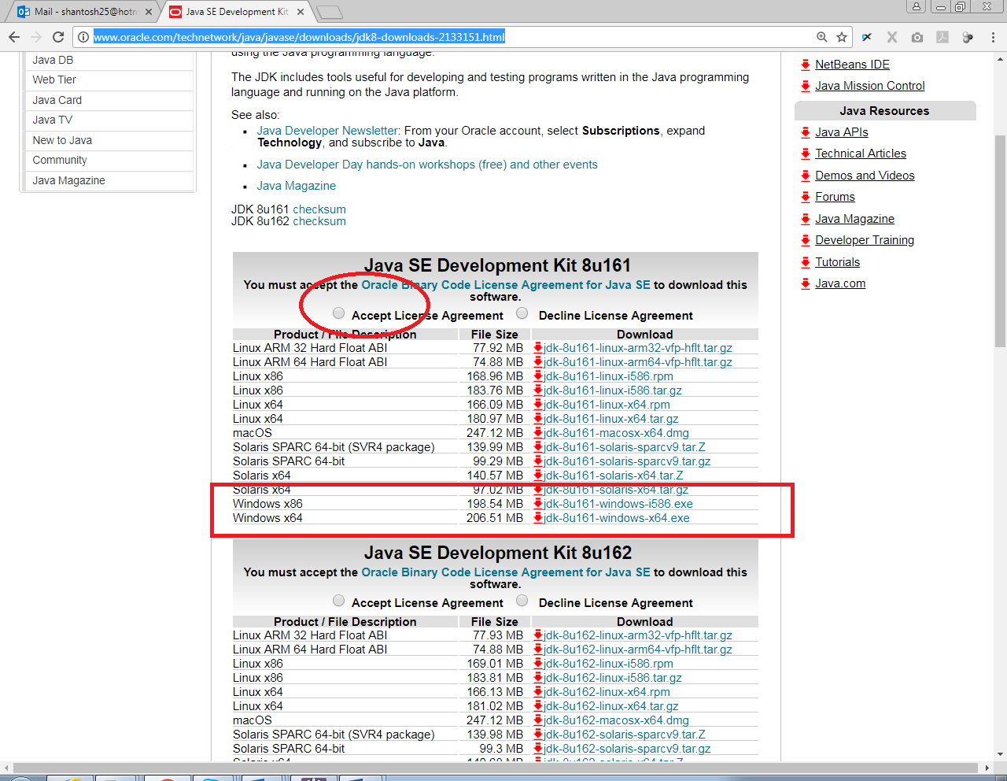

The downloaded file will look like this

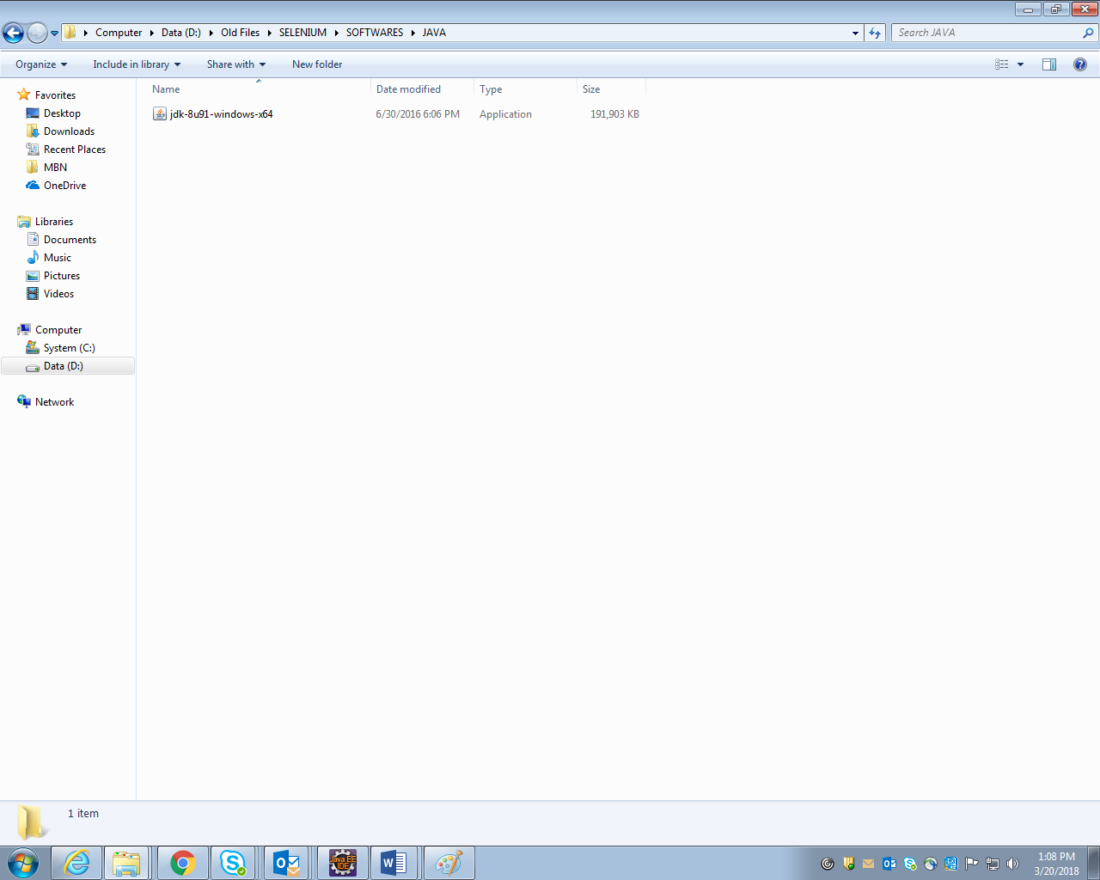

Double click on the downloaded file and proceed with the default options till finish.

Step 2: Once the installation is done set the class path.

For Mac users, it’s not required this is only for the windows user

2.1 HOW TO SET THE PATH?

Go to the drive where the java is installed. Example in my computer the java is installed in the C drive then go to C: Drive🡪Program files Folder🡪Java Folder🡪jdk1.7.0_25 Folder🡪Bin Folder and Click on the address bar and copy the path.

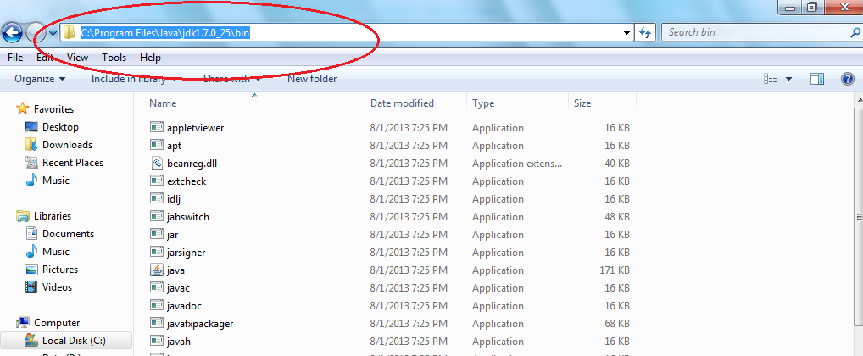

Now go to Start (Windows icon in the left corner) 🡪 Right click on My computer🡪 Click on Properties 🡪Click on Advance system settings and in Advance tab🡪Click on Environment Variables and in User Variable Section Click on New button and give the Variable name as “path” and in Variable value field paste the path copied previously (refer the above screen)

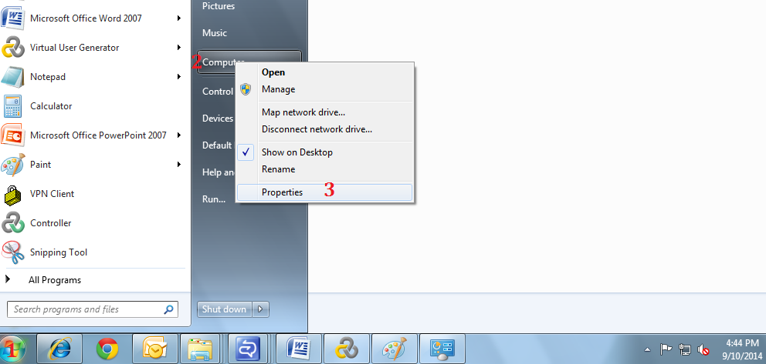

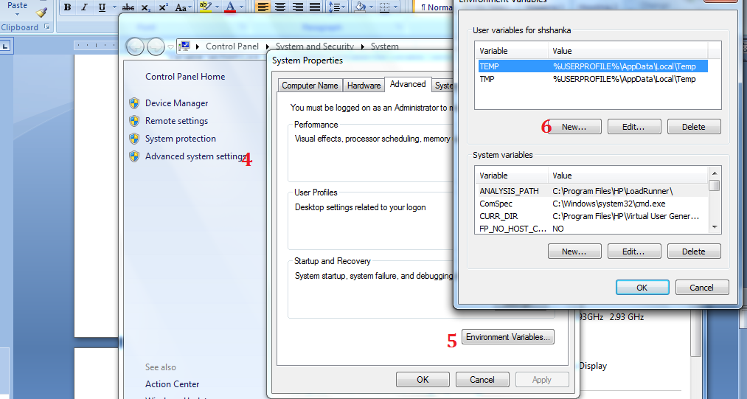

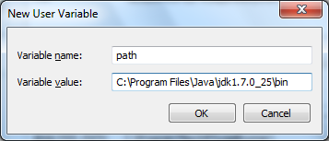

Click on OK in two places and click on Apply.

The other way to configure the path is follow the same steps as above but instead of User Variables go to System variables and from the files already added look for path variable as below

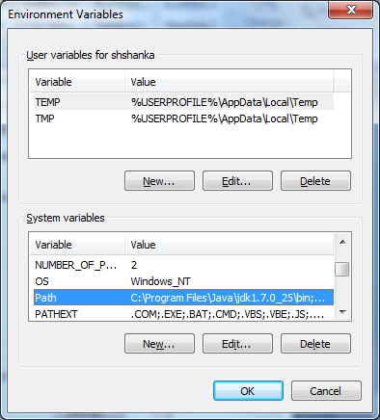

Click on edit button and in Variable value field and go to last. Use end button from the key board to go to last word in text field and then first put semi colon; and give the path copied earlier

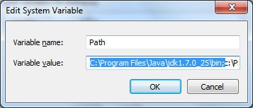

Download Eclipse IDE

Go to the below website and download the eclipe IDE depending on your OS and system architecture either 64 or 86 bit

<http://www.eclipse.org/downloads/packages/release/Neon/3>

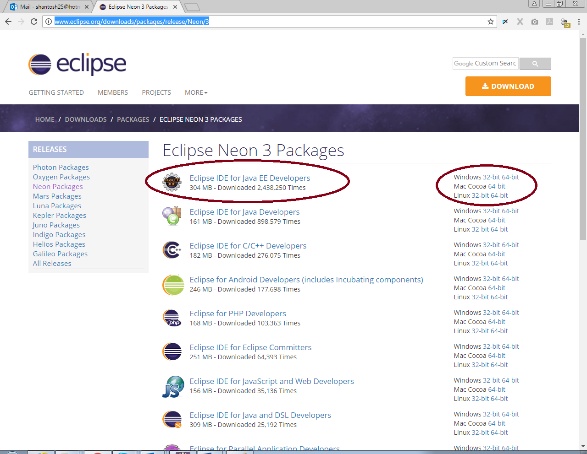

It will be downloaded as a zip file extract the file where ever you want it in your hard disk.

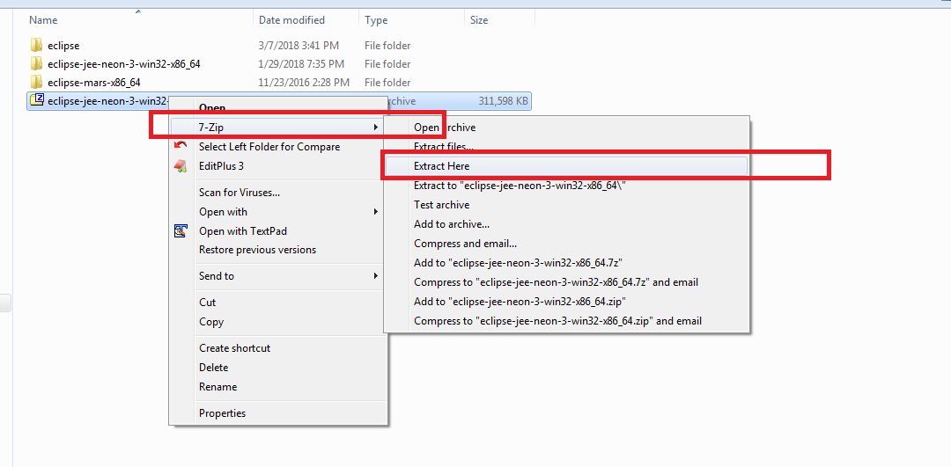

The latest version Oxygen will be an exe file just proceed with the normal installation